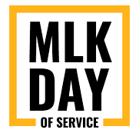

MLK Day of Service: "A Day On, Not A Day Off"!
Monday, January 18, 2021

Name of Organization:
Point of Contact: First Name: Last Name:
Title:
Phone Number:
Email:
Your MLK Day Activity Name:
Teaser line:
(Introduce your activity with a tidbit to catch everyone’s attention!)
Full Description:
(Describe your activity in full detail. Are materials provided or do participants need to gather supplies on their own? Where should finished projects be dropped off? Is this a family-friendly activity or more complex?)
Zoom Meeting Information:
Link:
Meeting ID:
Password (if applicable):
Please email finished form to lfikes@leadercenter.org by October 16th, 2020.

